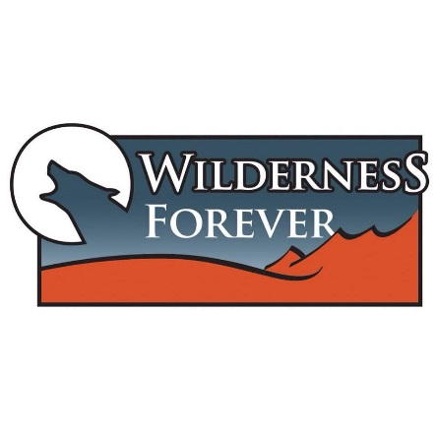
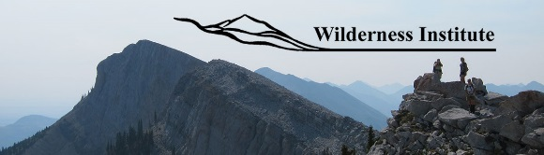

FOR IMMEDIATE RELEASE

CONTACT:

NATALIE DAWSON RACHEL JAMES ELIZABETH FRICKE
DIRECTOR, ASSISTANT DIRECTOR, SENIOR ASSISTANT DIRECTOR,
WILDERNESS INSTITUTE WILDERNESS INSTITUTE UM OUTDOOR PROGRAM
(406) 552-5550 (406) 243-6916 (406) 396-5108

University of Montana Freshmen Prepare for Campus Life in the Wilderness
Backcountry Service Trips Connect Students to Wildlands, Community, and Mentors

(Missoula, Mont. – August 27, 2015) Late yesterday, seventy-five University of Montana (UM) freshmen emerged from the Montana backcountry empowered, bonded, dirty, and ready for college, having made lifelong connections to wilderness, their Missoula home community, and each other.

Through the Freshman Wilderness Experience (FWE), sponsored by the Wilderness Institute and the UM Outdoor Program, eight groups of freshmen, each led by two trained student guides, spent four days and three nights in various wilderness areas around the state, completing service projects and performing group- and community-oriented tasks. In its second successful year, FWE is now part of UM’s freshmen orientation and draws many participants who have never camped before, let alone experienced a multi-day wilderness trip.

“Being able to arrive on campus one day not knowing anyone, and then return four days later having bonded with strangers in a wilderness setting was an amazing way to integrate into the school community. It gave me confidence to recognize faces during orientation, and the trip itself instills a confidence, as well, because you're completing physically strenuous tasks that challenge your body and your mind,” says Zoe Leake, a former FWE participant, who returned to the program this year as a student guide.

Natalie Dawson, Director of the Wilderness Institute, agrees. “This program allows the opportunity for new UM students to experience the wild landscapes that attracted many of them to this place.”

The Wilderness Institute, housed within UM’s College of Forestry and Conservation offers integrated, interdisciplinary, and experiential wilderness education to UM students and wilderness stewards around the globe. The FWE program not only fosters a strong community of learning across UM, but also supports the University’s continuing efforts to increase recruitment, provides mentorships with older students, and fosters a strong sense of place that can be developed by spending time in the wild lands surrounding Missoula.

Boston Wakeham, another student guide, said that “FWE is a program that allows those of us with experience to share our passion of land conservation and recreation with the next generation of land stewards.”

For more information about FWE or the Wilderness Institute, to interview FWE participants and student leaders, or to view photos from this year’s FWE trips, please contact Natalie Dawson, Rachel James, and/or Elizabeth Fricke at the numbers listed above.

