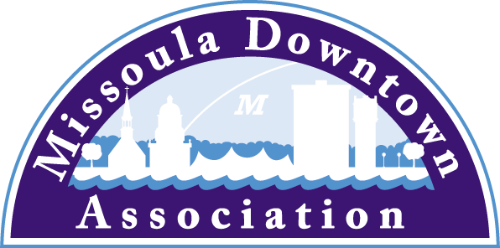

President
Heidi Starrett
Missoula Independent
Vice President: Advocacy
Aimee McQuilkin
Betty’s Divine
Vice President: Marketing & Events
Mario Schulzke
University of Montana
Vice President: Master Plan
Matt Ellis
Missoula Osprey/Uptown Diner
Vice President: Membership
Julie Tomasik
AAA Mountain West
Treasurer
Rick Eneas
Montana CDC
Past President
John Horner
First Interstate Bank

Trent Baker
Datsopoulos, MacDonald & Lind
Larry Brehm
Brehm Architecture
Anders Brooker
The Runner’s Edge
Lynda Brown
Brown HR Consulting
Ellen Buchanan
Missoula Redevelopment Agency
Dan Cederberg
Cederberg Law Offices, P.C.
Emily Costello
Treasure State Bank
Anne Guest
Missoula Parking Commission
Kim Klages-Johns
MSO Hub
Diane Lanning
Providence St. Patrick Hospital
Scott MacIntyre
Badlander Complex/Access ATM
Brooke Redpath
METTLE Strategic Marketing Solutions
Chad Strickland
Liquid Planet Downtown

Ex-Officio Representatives
Shane Stack
Montana Dept. of Transportation

Corey Aldridge
Mountain Line

218 East Main St., Suite C
Missoula, MT 59802
Phone: 406-543-4238
www.missouladowntown.com
info@missouladowntown.com

local/state
December 2, 2015

Downtown Missoula Parade of Lights Saturday, December 5
Santa’s Arrival at 1 pm at the Florence Building

The 13th Annual Parade of Lights will take place this Saturday, December 5, 2015 in Downtown Missoula. Santa will arrive in Downtown at 1 pm at the Historic Florence Building (111 N. Higgins) and will be available for photos and wish lists throughout the afternoon.

Produced by the Missoula Downtown Association and sponsored by Liquid Planet and Datsopoulos, McDonald and Lind and 16 additional businesses, the Parade of Lights will commence at 6 pm and travel from the Hip Strip north on Higgins to the Red XXXXs. The Lighting of the Downtown Tree will happen immediately thereafter.

The Parade of Lights draws thousands of folks to Downtown Missoula each year for the official kickoff of the holiday season. There are five award categories and parade entrants will be judged on overall appearance and impression, originality and creativity, use of lights, and enthusiasm. Award categories include Civic/Non-Profit, Commercial, Religious, High School/Collegiate, and K-8. Category winners receive an engraved plaque and will be promoted through the MDA newsletter and local media.

More than 20 Downtown destinations will host free or small fee ($1-$10) activities for children and their families to enjoy. Activities include:

Hip Holiday Market 10 am-5 pm Lowell School
Story Time 11 am Missoula Public Library
Beaded Snowflake Making 12-3 pm Bathing Beauties Beads
Christmas Card Making 12-3 pm ZACC
Popcorn Garland Making 12-3 pm KornUtopia
Snowman Craft 12:30-2 pm Children’s Museum Missoula
Horse Drawn Rides 1-5 pm East Pine Street
Family Yoga 12-2:40 pm Hot House Yoga
Holiday Braids, Bows & Buns for Kids 12-3 pm Boom Swagger Salon
Letters to Santa 1-3 pm Noteworthy Paper & Press
Drop-in Holiday Workshop 1-3 pm Missoula Art Museum
Drop In Crafts 1-4 pm Missoula Public Library
DIY Ornament Making 1-5 pm Upcycled
Cookie Decorating 1-5 pm Bernice’s Bakery
S’more Making & Carousel Rides 1-5 pm Carousel for Missoula
Classic Holiday Films 1-5 pm Roxy Theater
Santa Cookie Plate Making with the ZACC 2-4 pm Black Coffee Roasting
Chromatography & Neuron Making 2-5 pm SpectrUM Science Center
String Ornaments 2-5 pm La Stella Blu
Fortune Telling & Palm Reading 3-5 pm Betty’s Divine
Cupcake Decorating 3-5 pm Taste Buds Kitchen
Games, Face Painting, Card Making 4-6 pm Community of Saint Columba

The bonfire will be lit at 5 pm by Boy Scout Troop #1910, the Christian Life Center Choir will serenade the crowd, and there will be free coffee, cocoa, and cookies for all. Additionally, Downtown shoppers can get holiday gifts wrapped for free at the MSO Hub (140 N. Higgins).

For more information on the day’s activities, visit missouladowntown.com or call 406-543-4238.

Downtown Missoula: Connecting Our Community!

