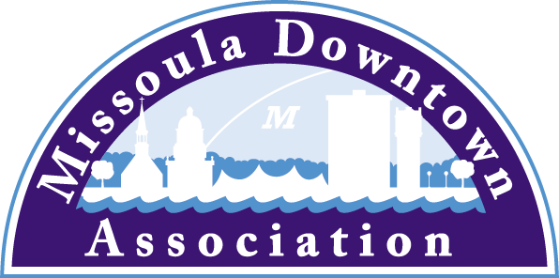
President
Aimee McQuilkin
Betty’s Divine
Vice President: Advocacy
Anders Brooker
Runner’s Edge
Vice President: Marketing & Events
Mario Schulzke
University of Montana
Vice President: Master Plan
Ellen Buchanan
Missoula Redevelopment Agency
Vice President: Membership
Julie Tomasik
AAA Mountain West
Treasurer
Rick Eneas
Montana CDC
Past President
Heidi Starrett
Missoula Independent
Trent Baker
Datsopoulos, MacDonald & Lind
Larry Brehm
Brehm Architecture
Lynda Brown
Brown HR Consulting
Dan Cederberg
Cederberg Law Offices, P.C.
Emily Costello-Kannady
Treasure State Bank
Matt Ellis
Missoula Osprey/Uptown Diner
Anne Guest
Retiree
John Horner
First Interstate Bank
Kim Klages-Johns
MSO Hub
Diane Lanning
Providence St. Patrick Hospital
Scott MacIntyre
Badlander Complex/GPA ATM
Brooke Redpath
METTLE Strategic Marketing Solutions
Chad Strickland
Liquid Planet Downtown

Ex-Officio Representatives
Corey Aldridge
Mountain Line
Rod Austin
Missoula Parking Commission

James Grunke
Missoula Economic Partnership
Shane Stack
Montana Dept. of Transportation
218 East Main St., Suite C
Missoula, MT 59802
Phone: 406-543-4238
info@missouladowntown.com

Sackett
Local/State/Special
May 16, 2016
Missoula

Philipsburg Brewing Company’s Rope Swing Saison Wins Best of Show, Best of Montana and Best Saison at the 24th Annual Garden City BrewFest

With over 70 beers on tap at this year’s Garden City BrewFest, the competition was steep. The refreshing Rope Swing Saison of Philipsburg Brewing Company captured the judges’ attention with its light, yet complex taste that contains a mixture of pepper, clove, fruit flavors, and a subtle tartness to form this French/Belgium style beer.

Local sponsor Bayern Brewing won Best Bock with Dump Truck. Hometown favorites The Front Brewing Company, Missoula Brewing Company and Bowser Brewing Company also won awards in the categories of Best Wheat, Best Stout/Porter and Best Scottish/Irish Red, respectively.

Congratulations to the winners and a big thank you to all of the participating breweries for providing great beer and extraordinary competition for the Downtown community to enjoy. Additionally, thanks to The Zoo City Zymurgists for providing their discerning palettes and judging the beers again this year.

“It was a beautiful day to enjoy some great brews,” said Andres Buitron of the Zoo City Zymurgists. “Like always, it was a great experience tasting and learning from these quality beers. Thanks again for allowing us to judge the event.”

Here is the complete list of the 2016 winners:

Category Beer Brewery
Best Light Lager Craft Lager Upslope Brewing Co.
Best Bock Dump Truck Bayern Brewing Inc.
Best Wheat Honey Weizen Front Brewing Co.
Best IPA Space Dust Elysian Brewing
Best Pale Ale Grunion Pale Ballast Point
Best Stout/ Porter Fortress Rock Imp Stout Missoula Brewing Co.
Best Fruit/ Specialty Mount Jumbo Grapefruit Missoula Brewing Co.
Best Scottish/ Irish Red Chip Off The ‘Ol Scotch Bowser Brewing
Best Saison/ Best of Show/ Rope Swing Saison Philipsburg Brewing Co. Best of Montana

For more information please visit missouladowntown.com
or the Zoo City Zymurgists website, missoulahomebrewers.org

Missoula Downtown - Connecting our Community

