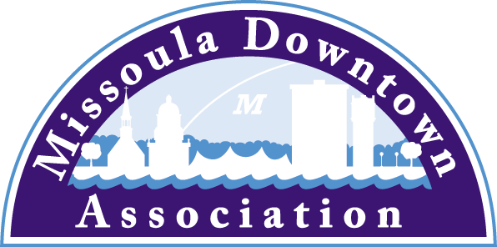
President
Aimee McQuilkin
Betty’s Divine
Vice President: Advocacy
Anders Brooker
Runner’s Edge
Vice President: Marketing & Events
Mario Schulzke
University of Montana
Vice President: Master Plan
Ellen Buchanan
Missoula Redevelopment Agency
Vice President: Membership
Julie Tomasik
AAA Mountain West
Treasurer
Rick Eneas
Montana CDC
Past President
Heidi Starrett
Missoula Independent
Trent Baker
Datsopoulos, MacDonald & Lind
Larry Brehm
Brehm Architecture
Lynda Brown
Brown HR Consulting
Dan Cederberg
Cederberg Law Offices, P.C.
Emily Costello-Kannady
Treasure State Bank
Matt Ellis
Missoula Osprey/Uptown Diner
Anne Guest
Retiree
John Horner
First Interstate Bank
Kim Klages-Johns
MSO Hub
Diane Lanning
Providence St. Patrick Hospital
Scott MacIntyre
Badlander Complex/GPA ATM
Brooke Redpath
METTLE Strategic Marketing Solutions
Chad Strickland
Liquid Planet Downtown

Ex-Officio Representatives
Corey Aldridge
Mountain Line
Rod Austin
Missoula Parking Commission

James Grunke
Missoula Economic Partnership
Shane Stack
Montana Dept. of Transportation
218 East Main St., Suite C
Missoula, MT 59802
Phone: 406-543-4238
info@missouladowntown.com

Regional/Local/Car Clubs
May 26, 2016
Missoula, MT
L. Wagener

Early Bird Registration Ends May 31 for Garden City River Rod Run

Beginning June 1, the registration fee for the 16th Annual Garden City River Rod Run will increase to $40. Through May 31, participants can register cars for the show and parade for $30 for the first car and $10 for additional cars. Participants can register cars online at www.missouladowntown.com/registercar.

The Garden City River Rod Run is slated for Friday and Saturday, June 24 – 25 and will feature over 200 classic and hot rod cars. Attracting nearly 3,000 spectators to Downtown Missoula, admission to the Garden City River Rod Run is free for spectators who can enjoy live music by Zoo City from 6 – 9 pm. The Show and Shine will take place on Friday evening from 5-9 pm followed by the Cruisin’ Parade on Higgins Avenue from 9-10 pm.

Saturday will feature a Show and Shine at Caras Park from 11 am – 4 pm with the awards presentation taking place at 3 pm. The award categories are Best Ford, Best Chevy, Best GM, Best Vintage, Best Street Rod, Best Special Interest, Best Pickup, Best Mopar and Best Buick. Best in Show and Sponsor’s Choice trophies will also be awarded.

This year, the Garden City River Rod Run will celebrate Buicks from the 1930s to the 1990s with 11 classic Buicks participating. Participants and spectators can purchase food from Baskin Robbins Ice Cream, Covered Wagon Hot Dogs, Polka Dot Patties, and Big Dipper Ice Cream and beverages will be available for purchase from the Badlander and Pepsi.

The Garden City River Rod Run is produced by the Missoula Downtown Association and sponsored by Bretz RV, Rick’s Auto Body, and Zip Beverage. For more information, visit missouladowntown.com/carshow or contact the MDA at (406) 543-4238 or info@missouladowntown.com

Schedule of Events
Friday, June 24 - Caras Park
Registration and Check-in 1-5:30 pm
Show & Shine 5-9 pm
Live Entertainment by Zoo City 6-9 pm
Parade Only Registration 7:30-9 pm
Cruisin’ Parade on Higgins Avenue 9-10 pm

Saturday, June 28 – Caras Park
Downtown Farmers Markets (along Higgins Ave) 8 am-1 pm
Registration and Check-in 9-11 am
Show & Shine 11 am-4 pm
Special Interest Awards Presentation 3 pm
Sponsor Awards Presentation 3:30 pm
End of Show 4 pm

Downtown Missoula: Connecting our Community!

