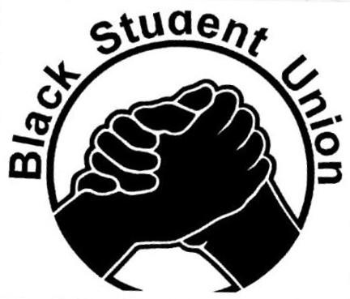
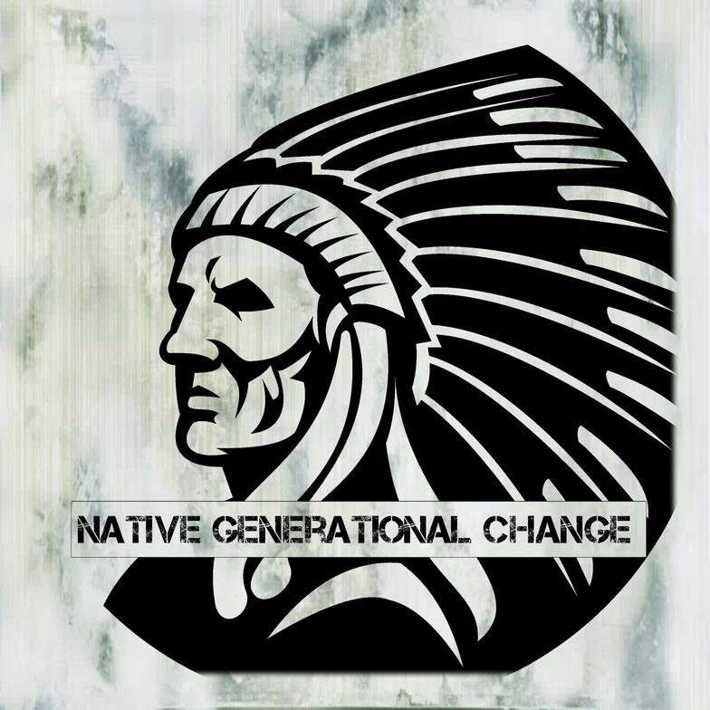

Voices For Justice Rally
FOR IMMEDIATE RELEASE
Media Contacts:
- Dustin Monroe - Native Generational Change - 406-493-5198 – dustin@nativegchange.org
- LeShawn Goerge - UM Black Student Union – 406-240-3933 – leshawn.george@umontana.edu

Missoula, MT - Native Generational Change and the University of Montana’s Black Student Union will be co-sponsoring the “Voices for Justice Rally” on September 22nd from 12pm to 1pm on the University of Montana Free Speech zone between the University Center and Mansfield Library.

“Native Generational Change is excited to be partnering with the Black Student Union,” said Dustin Monroe, Executive Director and Founder of Native Generational Change. “Both Native Americans and African Americans have been voices for racial justice from Fergusson to Standing Rock Reservation. In Missoula, MT on September 22, 2016, both groups of people are coming together to stand together for social justice for all.”

The “Voices for Justice Rally” (#voices4justice) main goal is to raise up the voices of People of Color here in Missoula just as the Black Lives Matter and Native Lives Matter movements have done so across the United States. Specifically, speakers at the rally will be talking about their personal stories of interactions with law enforcement to highlight the fact distrust exists between marginalized people (including people of color) and the police here in Missoula. Also there will be dialogue about the injustices happening currently on the Standing Rock Reservation and the effects on UM Native Students.

The long term goal of the rally is to begin a community wide dialog about building trust between the police and marginalized people based on accountability and responsibility. The Guardian has reported that so far in 2016 698 people of been killed by the police. That includes 107 people who were unarmed, 173 African Americans, 13 Native Americans and 4 people here in Montana.

“This is not about being anti-police,” said LeShawn George, President of the University of Montana Black Student Union. “Growing up my best friend's father was a police officer. But the truth is there is a lot of mistrust between all sorts of marginalized people and the police that is based on the real experiences that people are having in this community. We want to bridge this divide with a dialog led by the voices and experiences of people of color and other marginalized people.”

The “Voices for Justice Rally” will begin at 12pm at the University of Montana Free Speech zone between the University Center and the Mansfield Library. There will be speakers relating their experience with law enforcement as well as a reading of the names of African Americans and Native Americans who have been killed by the police. Participants will then be invited to march to the Madison Street bridge for a short vigil. More details of event can be found at https://www.facebook.com/events/650344201807272/

http://www.theguardian.com/us-news/ng-interactive/2015/jun/01/the-counted-police-killings-us-database

