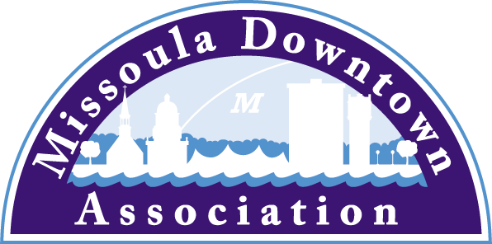
President
Aimee McQuilkin
Betty’s Divine
Vice President: Advocacy
Anders Brooker
Runner’s Edge
Vice President: Marketing & Events
Mario Schulzke
University of Montana
Vice President: Master Plan
Ellen Buchanan
Missoula Redevelopment Agency
Vice President: Membership
Julie Tomasik
AAA Mountain West
Treasurer
Rick Eneas
Montana CDC
Past President
Heidi Starrett
Missoula Independent
Trent Baker
Datsopoulos, MacDonald & Lind
Larry Brehm
Brehm Architecture
Lynda Brown
Brown HR Consulting
Dan Cederberg
Cederberg Law Offices, P.C.
Emily Costello-Kannady
Treasure State Bank
Matt Ellis
Missoula Osprey/Uptown Diner
Anne Guest
Retiree
John Horner
First Interstate Bank
Kim Klages-Johns
MSO Hub
Diane Lanning
Providence St. Patrick Hospital
Scott MacIntyre
Badlander Complex/GPA ATM
Brooke Redpath
METTLE Strategic Marketing Solutions
Chad Strickland
Liquid Planet Downtown

Ex-Officio Representatives
Corey Aldridge
Mountain Line
Rod Austin
Missoula Parking Commission

James Grunke
Missoula Economic Partnership
Shane Stack
Montana Dept. of Transportation
218 East Main St., Suite C
Missoula, MT 59802
Phone: 406-543-4238
info@missouladowntown.com
January 6, 2017
local media

Applications for 2017 Caras Park Pavilion Sponsorships Being Accepted
The Missoula Downtown Association, manager of the beloved Caras Park, is now accepting applications for the Caras Park Pavilion Sponsorship Program for the 2017 events season.

The goal of the Caras Park Sponsorship Program is to assist nonprofit organizations in producing community events at the Caras Park pavilion. The MDA is offering up to $3,000 in discounted rental rates to be divided among awardees. Individual awards are granted to nonprofit organizations whose event demonstrates a clear benefit to the Missoula community, brings a significant number of people to Downtown, and provides a positive image for Caras Park, Downtown, and Missoula.

Historically, these sponsorships have been used to retain annual events in the pavilion, but with the ushering in of a new year, the MDA invites new concepts and community events for 2017 to apply for consideration.

Interested parties are invited to learn more about the program and apply online by visiting www.missouladowntown.com/carasparksponsorship. Applications must be received by Friday, February 10, 2017 to be considered for the program. All requests will be reviewed and decided by the Missoula Downtown Association Board of Directors, and Sponsorship winners will be announced no later than March 10, 2017.

For more information on the sponsorship program, Caras Park Rentals, or membership with the Missoula Downtown Association, please contact us via phone (406.543.4238) or email (info@missouladowntown.com).

Missoula Downtown Association: Connecting Our Community!

