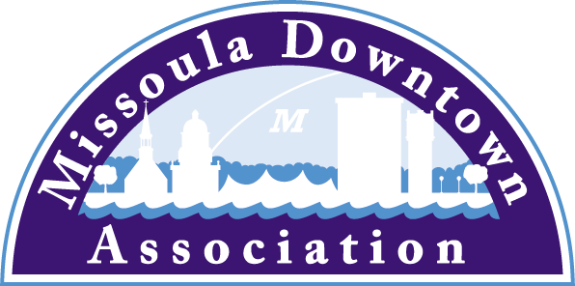
218 East Main St., Suite C
Missoula, MT 59802
Phone: 406-543-4238
info@missouladowntown.com

President
Anders Brooker
Runner’s Edge
Vice President: Advocacy
Emily Kannady
First Security Bank
Vice President: Marketing & Events
Brooke Redpath
METTLE Strategic Marketing Solutions
Vice President: Master Plan
Ellen Buchanan
Missoula Redevelopment Agency
Vice President: Membership
Lynda Brown
Brown HR Consulting
Treasurer
Ben Wright
Montana CDC
Past President
Aimee McQuilkin
Betty’s Divine

Trent Baker
Datsopoulos, MacDonald & Lind
Larry Brehm
Brehm Architecture
Dan Cederberg
Cederberg Law
Matt Ellis
Missoula Osprey/Uptown Diner
Katie Ghen Simpson
Bathing Beauties Beads
Anne Guest
Retiree
John Horner
First Interstate Bank
Kim Klages-Johns
MSO Hub
Diane Lanning
Providence St. Patrick Hospital
Paige Livingston
One Eleven
Scott MacIntyre
Badlander Complex/GPA ATM
Bob McGowan
Rocky Mtn. School of Photography
Mario Schulzke
University of Montana
Tom Snyder
Five on Black
Heidi Starrett
Missoula Broadcasting

Ex-Officio Representatives
Corey Aldridge
Mountain Line
Rod Austin
Missoula Parking Commission
James Grunke
Missoula Economic Partnership
Shane Stack
Montana Dept. of Transportation

February 28, 2017
Local/state Media
L. McCarthy

APPLICATION PERIOD OPEN FOR
OUT TO LUNCH AND DOWNTOWN TONIGHT SUMMER SERIES

One of the best things about summer in Missoula is the Out to Lunch and Downtown ToNight Summer Series that take place every Wednesday afternoon and Thursday evening in June, July and August in Caras Park.

The Missoula Downtown Association is gearing up for the 2017 summer season, and the deadline to apply for both food vending and entertainment for these beloved summer events that draw thousands of folks to the heart of Missoula is fast approaching.

Folks interested in vending or performing at Out to Lunch and/or Downtown ToNight can apply online here: https://www.missouladowntown.com/play/mda-events.

Vendors are selected based upon food offerings, experience, power needs, professionalism and ability to enhance the event. Vendors pay an upfront fee and a percentage of their weekly sales. This year the MDA is offering a pilot project for “guest” vendors, where a select number of vendors are chosen as guests for a specific number of events.

Performers are selected based upon type of music, price-point, popularity in the Missoula marketplace, professionalism, sound and appeal to folks of all ages. Performances are typically three hours in length on the outdoor stage in Caras Park, and performers are paid for their talent.

The Missoula Downtown Association uses MDA member Submittable for its online application for entertainment, so folks can upload media files with their application materials. The vendor application is a PDF that must be printed, completed and submitted with payment, business license, proof of insurance, and application for a Temporary Food Service (TFS) permit, if necessary.

Bands and vendors are selected by each program’s organizing committee, comprised of volunteers from the MDA membership.

This year marks the 32nd year of Out to Lunch and the 17th year of Downtown ToNight. Both programs are admission-free and accessible to all, thanks to the generous businesses who sponsor each event.

Questions can be directed to the Downtown Missoula Partnership via phone (406-543-4238) or via email (info@missouladowntown.com).

Downtown Missoula: Connecting Our Community!

