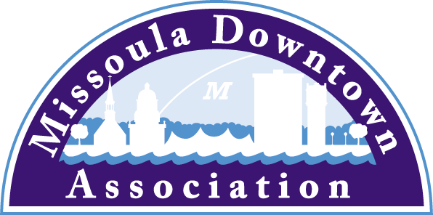
218 East Main St., Suite C
Missoula, MT 59802
Phone: 406-543-4238
info@missouladowntown.com

President
Anders Brooker
Runner’s Edge
Vice President: Advocacy
Emily Kannady
First Security Bank
Vice President: Marketing & Events
Brooke Redpath
METTLE Strategic Marketing Solutions
Vice President: Master Plan
Ellen Buchanan
Missoula Redevelopment Agency
Vice President: Membership
Lynda Brown
Brown HR Consulting
Treasurer
Ben Wright
Montana CDC
Past President
Aimee McQuilkin
Betty’s Divine

Trent Baker
Datsopoulos, MacDonald & Lind
Larry Brehm
Brehm Architecture
Dan Cederberg
Cederberg Law
Matt Ellis
Missoula Osprey/Uptown Diner
Katie Ghen Simpson
Bathing Beauties Beads
Anne Guest
Retiree
John Horner
First Interstate Bank
Kim Klages-Johns
MSO Hub
Diane Lanning
Providence St. Patrick Hospital
Paige Livingston
One Eleven
Scott MacIntyre
Badlander Complex/GPA ATM
Bob McGowan
Rocky Mtn. School of Photography
Mario Schulzke
University of Montana
Tom Snyder
Five on Black
Heidi Starrett
Missoula Broadcasting

Ex-Officio Representatives
Corey Aldridge
Mountain Line
Rod Austin
Missoula Parking Commission
James Grunke
Missoula Economic Partnership
Shane Stack
Montana Dept. of Transportation

Sackett
Local/State/Special
April 12, 2017
Missoula , MT

25th ANNUAL GARDEN CITY BREWFEST
SLATED FOR SATURDAY, MAY 6, 2017 IN CARAS PARK

The 25th annual Garden City BrewFest will take place Saturday, May 6, 2017 in Caras Park from noon to 8 pm. The Garden City BrewFest again serves as the grand finale of the 6th annual Missoula Craft Beer Week. Garden City BrewFest started 25 years ago by five people who had no idea that the event would soon become a signature, must attend event in Missoula. Garden City BrewFest is proudly sponsored by Bayern Brewing Company, Farmer’s State Bank, Gecko Designs, The Trail 103.3, the Missoula Independent, McLean Properties, and Montana Distillery.

This year’s Garden City BrewFest will feature over 70 draft beers, as well as a wine bar, making it the largest beer fest in Montana. This year’s beers will be an assortment of local favorites as well as some of the best regional beers. The greatest variety of beer will be available early in the day as some beers are limited release. Early attendance is encouraged.

“Garden City BrewFest is the perfect way for the Missoula community to come out and finally embrace the warm, spring weather and get excited for the upcoming summer,” said Emily Kannady, Garden City BrewFest committee chair. “With the immense support from our community, the event has grown to its successful status of being Montana’s largest BrewFest and with such a vibrant energy surrounding the entire event it’s evident why it’s such a success. So don’t miss this event, you’ll be devastated if you do!”

The event will also feature many of Missoula’s favorite musicians and bands. Rotgut Whines kicks off the event from 12-2 pm followed by Letter B from 2:30-5 pm. The Dodgy Mountain Men will wrap up the event from 5:30-8 pm.

As in the past, admission to the event is free. Those who want to sample beer must purchase a 7-ounce commemorative glass, wristband, and three beer tokens for $15. Additional beer tokens are two for $3. For $20, you can buy a glass and seven tokens. Designated Drivers receive free water and soda for the duration of the event and a designated driver white wristband is available at each entrance. For those who enjoy tasting the delicious brews, patrons are encouraged to park in the Park Place and Central Park structures, which offer free parking on weekends. Mountain Line also provides Zero-Fare transit service on all routes. We encourage folks to call a cab or order an Uber ride for a safe ride home.

The beer selection will be complemented by a lineup of some favorite local food vendors, including Clove Cart Pizza, Covered Wagon Hot Dogs, Dobi’s Teriyaki, El Cazador, Wally & Buck, and What’s a Viking.

All of the beers at BrewFest will be judged by the Zoo City Zymurgists - Missoula’s local home brew club. The Zymurgists will select winners in a variety of categories, from which they pick a “best in show” beer.

More information can be found online at www.missouladowntown.com or by contacting the MDA staff via phone (543-4238) or email (info@missouladowntown.com).

Missoula Downtown - Connecting Our Community

