Grain Free Living
- Want more energy and vitality?
- Do you have seasonal allergies or food allergies?
- Do you simply want a better understanding of the foods you consume?
- Or perhaps you are tired of fad diets, media myth, and marketing geared to appeal only to your desires: this workshop might interest you.

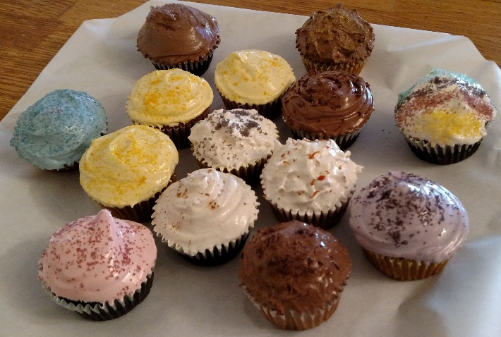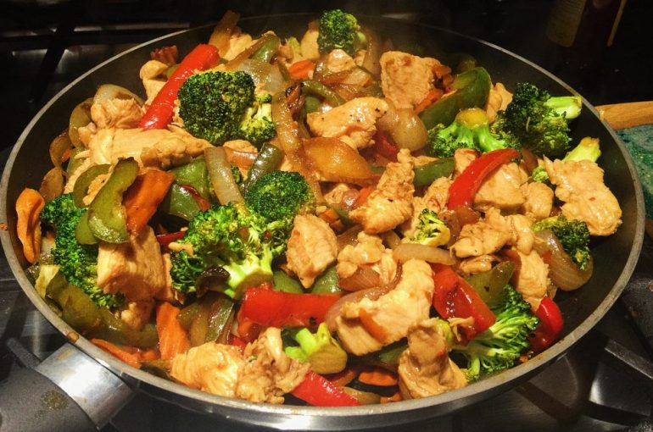
Attend free of charge August 19th
Held at the Missoula public library meeting room right across from the downstairs computer lab running from 3:00pm-4:30 pm.
A small selection snack examples of Grain free living will be provided free of charge.

The event is taught and hosted by Andrea A. Fitzpatrick
Contact info email: namewag@outlook.com

