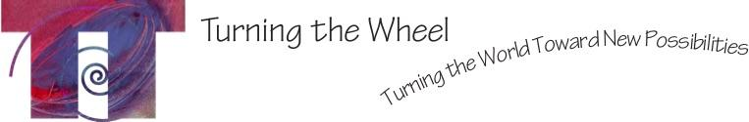

FOR IMMEDIATE RELEASE Contact: Lulu Delphine
Phone: 406.544.7561
Email: lulu@turningthewheel.org

ENCHANTED FOREST
AN ART FILLED CELEBRATION OF WONDER AND CREATIVITY

WHAT: Enchanted Forest, a dance party, interactive art and performance event. Costumes welcome!
WHEN: 7pm - midnight Saturday, October 27, 2018
WHERE: MASC Studio, 1200 Shakespeare, Missoula

Enchanted Forest is a costume friendly interactive art and performance evening. The early part of the evening will invite event- goers to create at arts stations, guided by fantastical characters. There will also be a series of performances, including flamenco, spoken word poetry, aerial silks, parkour, drumming, tribal fusion belly dance and more. In the latter hours, the floor will open to a DJ’d dance party. Enchanted Forest celebrates the wonder and creativity of Halloween while also raising funds for Turning the Wheel Missoula’s body-based wellness and essential life skills work with local youth. Enchanted Forest takes place Saturday, October 27 from 7pm – midnight at MASC Studio, located at 1200 Shakespeare in Missoula. Enchanted Forest seeks to give event-goers the experience of what makes them come alive.

Funds raised at Enchanted Forest will support TTWM’s work with freshman Health classes at Sentinel High School. They will be learning body based life skills for self-awareness, self-care and self-expression. In the process, they will explore leadership, collaboration, learning through physical activity and stress relief. Like good nourishment to growing brains and bodies, Turning the Wheel Missoula supports teens to evolve into healthy, engaged community members.

Tickets available at https://www.universe.com/events/enchanted-forest-tickets-missoula-JMHS3Q?ref=explore
OR universe.com search “Enchanted Forest”

Turning the Wheel Missoula is a non-profit organization that uses movement and creative expression as the catalyst for vibrant, healthy communities.

###

