FOR IMMEDIATE RELEASE:

Dance and music of Guinea, West Africa comes to UM and the Missoula community, brought to you by the UM School of Theatre & Dance and Unity Dance & Drum

Master Dancer Alhassane Camara, and Master Drummer/Musician Mory Fofana will be sharing their deep traditional knowledge of the music and dance traditions of Guinea through classes and a performance in Missoula October 1 through 4 at the UM School of Theatre & Dance and in the Missoula community. All ages and levels are welcome to join this unforgettable cultural experience.
Please contact Tarn Ream for more information.

Tarn Ream, Unity Dance and Drum
(406) 549-7933
tarn.ream@umontana.edu

Missoula schedule for Alhassane and Mory

*All University of Montana (UM) classes will be taught in PARTV005 (Open Space) *Free for UM students; $20 for community

Tuesday, October 1
UM dance class: 2:00-3:20pm
UM dance class: 4:30-6:00pm
Community Dance Class: 7-8:30p @ Missoula Senior Center $20/person; $10 Student/Senior

Wednesday, October 2
UM dance class: 2:30-3:50pm
UM dance class: 4:00-5:20pm
Community Drum class: 7:00-8:30pm @ Missoula Senior Center $25/person; $10 Student/Senior
(some drums available on a first come, first served basis)

Thursday, October 3
UM dance class: 4:30-6:00pm [choreography/Adv.]
Community Dundun Drum/Dance Class*: 7:00-8:30pm @ PARTV Open Space (Room 005), UM Campus $20/person; UM students free.
* play drums with sticks while dancing (some drums and sticks available on a first come, first served basis)

Friday, October 4
UM dance class: 1:00-2:20pm
Performance/Presentation @ UM Open Space (PARTV005): 7:00pm
UM students free; $5 to $10 suggested donation

*Mory and Alhassane are available to teach private classes upon request.
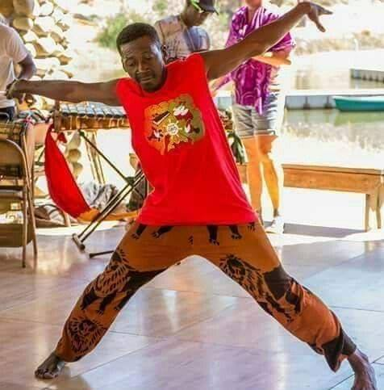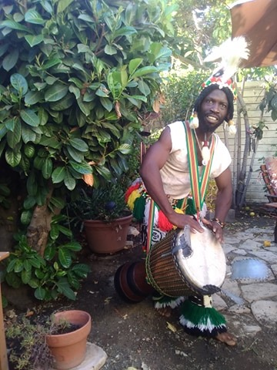

Alhassane Da Camara was born in Conakry, Guinea, West Africa. His mother, Da Camara, was a dancer, and Alhassane has been blessed with the same innate talent. Following his calling, Alhassane was fully immersed in Ballet Tayely by the age of 11—studying and performing traditional Guinea dances. He continued to excel, not only as a dancer, but as a fully trained musician, knowing all of the musical rhythms of the drums and accompanying instruments of the traditional dances. Youssouf Koumbassa, master dancer of Guinea, took Alhassane under his wing, embraced his talent, and appreciated his dedication and determination. Alhassane has worked extensively with Youssouf, and is honored to be considered his protégé. Alhassane arrived in the USA in 2009 and now lives in Oakland, CA. Alhassane embodies the spirit of Guinea dance and shares his gifts of grace and creativity in a beautiful, high energy dance class, full of smiles. Inspiration is inevitable in his uplifting presence.

Mory Fofona was born in Conakry, Guinea, and started playing drums at the age of 5. Between the ages of 10 and 15, he traveled around West Africa with group Saamato, performing and teaching dance and drum. Mory has performed with many different companies, including Les Ballet Africains, Ballet Jolleba, Koukoure Bamba, Ballet Solie D’ Afrique, Merveille De Guinea, and Gbessi Colo. Mory also toured with Wofa for five years before settling in the U.S. He is currently the Executive Director of Boremali FanyinFan West African Drum & Ensemble and works with various African drum and dance companies within the US and all over the world. To see Mory play drums is to see a master at work—he is a versatile player who can play many styles of music.

