What will you do if your best friend steps in a trap?

Traps are hidden and baited. Traps are indiscriminate. Traps can be almost anywhere.
PUBLIC SAFETY
What You Need to Know
__________________________________________
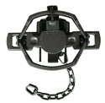
LEARN
•Trapping regulations

• How to avoid traps

• First Aid

• Hands-On Practice releasing traps

• What to carry with you to save your pet

TRAPPED!
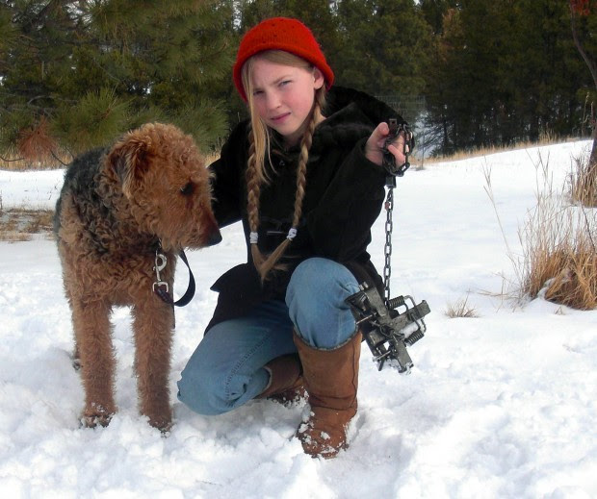 Polly the Airedale has survived three traps.
SUNDAY, JAN 5, 1- 3 PM • TUESDAY JAN 21, 7 -9 PM
Trap-Release Workshops
Presented by Footloose Montana

Humane Society of Western Montana
5930 US Hwy 93, Missoula, MT 59804 • 406-549-3934

FREE AND OPEN TO THE PUBLIC
WWW.footloosemontana.org • 406-282-1482 • Find us on Facebook

