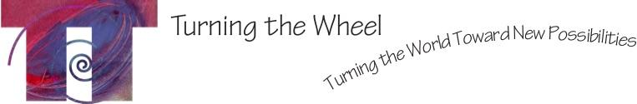

FOR IMMEDIATE RELEASE
Contact: Marlena Weiss
Phone: 760.560.6434
Email: marlena@turningthewheel.org

TAPESTRY: WEB WEAVERS
A GUIDED MOVEMENT ZOOM CLASS WITH TURNING THE WHEEL

WHAT: Tapestry, a guided improvisational movement class via Zoom
WHEN: 5:30PM -7:00PM MST, Thursday, May 21, 2020
WHERE: Zoom, virtual meeting platform

Tapestry is a guided movement improvisation class, for ages 16 and older. It is designed to inspire creative collaboration, personal awareness and the aliveness that is integral to community. Living room led by Lizzi Juda and Lulu Delphine of Turning the Wheel Missoula, with live music by Jesse Manno, the class will inspire new ways to interact with yourself in your home while connecting you to participants across the country. Tapestry: Web Weavers takes place on Thursday, May 21, 2020 from 5:30-7:00pm via Zoom.
Turning the Wheel Missoula is a non-profit organization that offers programs to students, elders and professionals of all ages and abilities in movement arts and embodied education. We are cross disciplinary: one part community engagement, one part health and wellness and one part arts education. Our goal is to nurture vibrant individual and community health through creative expression.
$15 suggested donation, but please pay what you can. To receive the Zoom link, please register at https://secure.lglforms.com/form_engine/s/95X9hbus7n97sar5R2EuFw or through Venmo @TTWMissoula. Please include your email address in the memo if payment made through Venmo.

Turning the Wheel Missoula is dedicated to fostering the social, emotional and physical health for all people.

###

