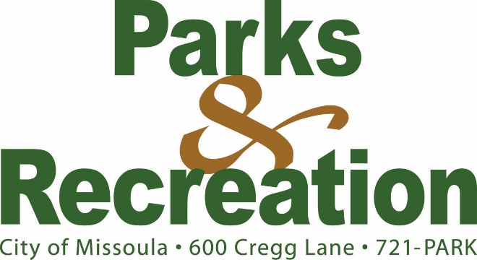

May 8, 2020
Local Media

PUBLIC INPUT NEEDED FOR NORTH RIVERSIDE PARKS & TRAILS PLAN;
DIGITAL PRESENTATION OPENS ONLINE MAY 13

All Missoulians are invited to view the virtual reveal of the North Riverside Parks & Trails Plan and provide feedback on the draft plan through the online survey. The virtual presentation, located online at https://www.engagemissoula.com/north-riverside-parks-trails, will be open for public viewing from May13-27, and all Missoulians are encouraged to provide input.

The plan will be presented by Dover, Kohl & Partner’s Jason King, members of the design team, city staff, and steering committee members in short, consumable videos. The design concepts focus on Downtown parks and trails located on the north side of the Clark Fork River from Russell Street to Missoula College, including Ron’s River Trail. The presentation will be broken down into short videos with an online survey for the public to provide feedback and input on the plan. The team will also talk about how the current pandemic affects public spaces and how to incorporate the advice of health experts into the proposed designs.

An additional component of the 2019 Downtown Missoula Master Plan Update, the North Riverside Parks & Trails Plan provides more finite details and design concepts for the city center parks and riverfront trail with a focus on more year-round opportunities for residents and guests.

The plan focuses on five major goals:
- Improve gateways and circulation
- Update materials, elements and landscaping, including plantings and art
- Improve views and access points to the Clark Fork River
- Support existing uses and design multi-functional spaces
- Design parks for everyone and for all seasons

“During the Downtown Master Planning process, we heard immense enthusiasm for parks and trails, so we have designed concepts we think will meet future needs,” said Donna Gaukler, Director of Missoula Parks & Recreation. “Now is the time to voice priorities for these valued parks, trails, as well as the Clark Fork River through Downtown.”

For more information on this or the Downtown Master Plan, visit www.missoulasdowntownmasterplan.com or contact Nathan McLeod with Missoula Parks & Recreation via phone (552-6261) or email (mcleodn@ci.missoula.mt.us).

