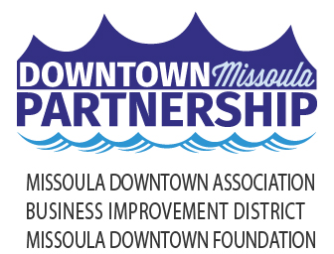

Local Media

November 21, 2022

**PUT YOUR MONEY WHERE YOUR HEART IS**

**Support Local Businesses During Small Business Season**

Small businesses are the backbone of the Missoula-area economy and Missoulians are once again asked to “Put Your Money Where Your Heart Is” by shopping and dining in Downtown Missoula during ***Small Business Season,*** starting with ***Small Business Saturday*** on November 26.

Small Business Saturday was created in 2010 to encourage people across the country to support small businesses. As a counter to Black Friday following the Great Recession, the Shop Small Movement grew from one company’s promotion to a nationwide-movement to support small businesses on Main Streets and in downtowns across America.

In recent years, there has been a more finite focus on how small businesses - created and sustained by local Missoulians - build strength, diversity, creativity and sustainability in our local economy. Making purchases at locally-owned small businesses keeps dollars circulating in our own community and economy. Supporting our neighbors and friends who own local businesses provides resources to those who give time and time again to our local non-profits, schools, sports teams and community initiatives. Spending money at small businesses in Missoula means those businesses can keep their doors open, their people employed and their families fed.

Alongside nearly 200 small restaurants and retail stores, the Missoula Downtown Association (MDA) will be welcoming those who join in the “Put Your Money Where Your Heart Is” movement to Downtown during Small Business Saturday. The Shop & Dine Local Headquarters will be at the corner of Higgins and E. Main from 10am-2pm. Coupons for complimentary hot chocolate, branded shopping bags and handouts with the Downtown specials will be available for pickup in front of the Paddleheads Post (140 North Higgins).

Looking for the perfect gift? The Missoula Downtown Gift Card also supports locally-owned, Downtown businesses. Accepted at over 200 locations, it’s the most versatile gift in Missoula. In 2021, over $570,000 in Downtown gift cards were sold, which means over half a million dollars will be put into the hands of local businesses when the gift cards are redeemed. Missoula Downtown Gift Cards can be bought at the Downtown Missoula Partnership (218 E. Main), the Paddleheads Post (140 N. Higgins) or online at missouladowntown.com/downtown-gift-cards/.

Adding to the ***Small Business Season*** atmosphere, the Downtown Missoula Window Decorating Contest will be open for public voting starting Friday, Nov. 25 and continues through Thursday, Dec. 15. It’s a great opportunity to walk around and enjoy holiday decorations with friends and family while shopping and dining in Downtown.

For more information on ***Small Business Season*** and other holiday happenings in Downtown Missoula, visit [www.missouladowntown.com](http://www.missouladowntown.com), email [info@missouladowntown.com](mailto:info@missouladowntown.com), or call the Downtown Missoula Partnership office at 406-543-4238.

*Downtown Missoula: Connecting Our Community!*