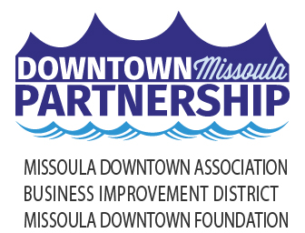

Local Media

August 16, 2023

**17TH ANNUAL RIVER CITY ROOTS FEST CELEBRATES MISSOULA**

**THE TRAVELIN’ MCCOURYS TO HEADLINE ADMISSION FREE FESTIVAL**

Music. Art. Food. Community. All the ingredients that make up the Missoula Downtown Association’s River City Roots Festival returns to the streets of Downtown Friday and Saturday August 25-26. This annual event celebrates everything that makes Missoula, *Missoula*. Supported in part by title sponsors *First Interstate Bank* and *Dick Anderson Construction*, Missoula’s Signature event is admission-free and features live music, an art show, the Family Roots Fest, the 4-Mile Roots Run, and local food vendors.

“Roots Fest is truly all about Missoula,” said Ellen Buchanan, Chair of the Roots Fest Committee and member of the Missoula Downtown Association Board of Directors. “This festival showcases some of the attributes that makes our city so unique and vibrant, such as music, art, being active, and a sense of community. Roots is something that everyone can enjoy thanks to our admission-free model and we take great pride in that. Downtown is the heartbeat of our community and we want to make sure everyone has a chance to experience all the best things it has to offer.”

**Music on Main** – Sponsored by *Big Sky Brewing*, *Blackfoot Communications*, and *HDR* – music begins at 12:30 pm both days. This year’s lineup features a wide variety of local and national roots music artists with five bands playing each day. It has become a tradition to open Main Stage at 12:30pm both days with music by and for Missoula’s youth. This year is no exception with music from kids’ rock bands kicking off the festival on Friday, thanks to **Tangled Tones** and the **Zootown Arts Community Center** (ZACC) and Saturday features **Cowboy Andy & the Salamanders**. Friday features two Montana based bands – **Joan Zen** of Missoula and **Soul Funk Collective** from Billings. **Taj Weekes & Adowa**, hailing from the Caribbean, takes the stage at 6:30pm; this will be their second time on the Roots Fest stage. Closing out Friday is headliner **Super Chikan**. A native of Mississippi, this will be James “Super Chikan” Johnson’s second Roots Fest stint, the first being in 2021.

**Fireside Collective** takes the stage at 1:30pm on Saturday and is followed by the up-and-coming Montana-based band **Laney Lou & the Bird Dogs** taking the stage at 4:30pm. **Big Richard** – who self-describes themselves as “bluegrass with a side of lady rage” – is quickly rising in popularity across the country and takes the Roots Fest stage for the first time at 6:30pm. Closing out the festival at 8:30pm is **The Travelin’ McCourys**. Fronted by brothers Ronnie and Rob, they come from bluegrass royalty as the sons of Del McCoury.

The **Art Show** will open the festival at 12pm on Friday and features over 35 local and regional artists selling hand-made goods, including jewelry, pottery, prints, leather works, wood, paintings, soap, clothing and more. One of the highlights of the Art Show is the opportunity to work with Missoula’s own Clay Studio; attendees can create their own piece of art to take home. The Art Show is sponsored by *Art Vault*, *Berkshire Hathaway*, *Horizon Credit Union*, and *The Wren Hotel*.

The **Roots Run** is held on Saturday, August 26 at 8:30 am, starting on east Main Street and ends in Caras Park. Produced by *Run Wild Missoula* and sponsored by *DJ&A Engineers*, *First Security Bank*, *Good Food Store, and the Runner’s Edge*, the Roots Run is a unique four-mile distance that crosses the Clark Fork River four times. Runners and walkers of all ages and paces are encouraged to participate. Registration can be found at www.runwildmissoula.org/races/river-city-roots-run/.

The **Family Fun Fest** – sponsored by *Children’s Dentistry of the Rockies* and *TDS Fiber* – runs from 10am to 2pm Saturday, August 26 in Caras Park. Families will find more than 20 local kid-friendly organizations offering activities and performances.

As a showcase of **Green Initiatives**, Roots Fest has several sustainability practices that are standard - thanks to sponsors *Dorsey Whitney*, *Mountain Line, Republic Services* and *WGM Group*. A carbon-neutral stage, compostable materials required for all vendors, reusable aluminum cups, steel pint commemorative cups, and recycling and composting are all part of the festival. Zero-fare bus service with Mountain Line and bike parking help reduce the impact of driving and parking, and the Green Team provides immense support for the festival thanks to efforts by *Home ReSource*. A bike valet, thanks to *Missoula in Motion*, will be available from 6 – 10:30pm both days.

**Food & Beverages** will be offered throughout the festival. Over a dozen local food trucks will be open on Ryman Street throughout the event. Local favorites such as *El Cazador*, *Kamoon*, *M-80 Chicken*, *Mountain Berry Bowls*, *River City Eats*, and *Big Dipper Ice Cream* will be among the options. *Badlander Catering* will have a variety of adult beverages, and all who choose to imbibe will need a Roots Fest wristband and cup.

Back again for 2023 is the **Unseen Missoula Music Tour**: *“This Town is Full of Ghosts”*. This guided walking tour will highlight several destinations in Downtown Missoula that have played a significant role in Missoula’s musical history. The tours will be offered on Friday, August 25 at 3pm and on Saturday, August 26 at 10am and 3pm. Information and registration for the tours will be available at [www.missouladowntown.com/unseen-missoula](http://www.missouladowntown.com/unseen-missoula).

Roots Fest is admission free and accessible for all, thanks to over 30 Missoula businesses who financially support the festival as sponsors. As the signature celebration of the city we love, all attendees are encouraged to remember to be kind and thoughtful while enjoying the festival. Be kind to the volunteers and servers, don’t bring your pets, and enjoy all the wonderful things this festival offers our community. While folks are encouraged to bike, walk and bus to the festival, parking will be free throughout Downtown on Friday, Aug. 25, thanks to the generosity of the *Missoula Parking Commission*.

The full River City Roots Fest schedule follows. For more information, visit [www.rivercityrootsfestival.com](http://www.rivercityrootsfestival.com) or contact the Downtown Missoula Partnership office via phone (406-543-4238), email ([info@missouladowntown.com](mailto:info@missouladowntown.com)) or in person (218 E. Main St).

*Downtown Missoula: Connecting Our Community!*

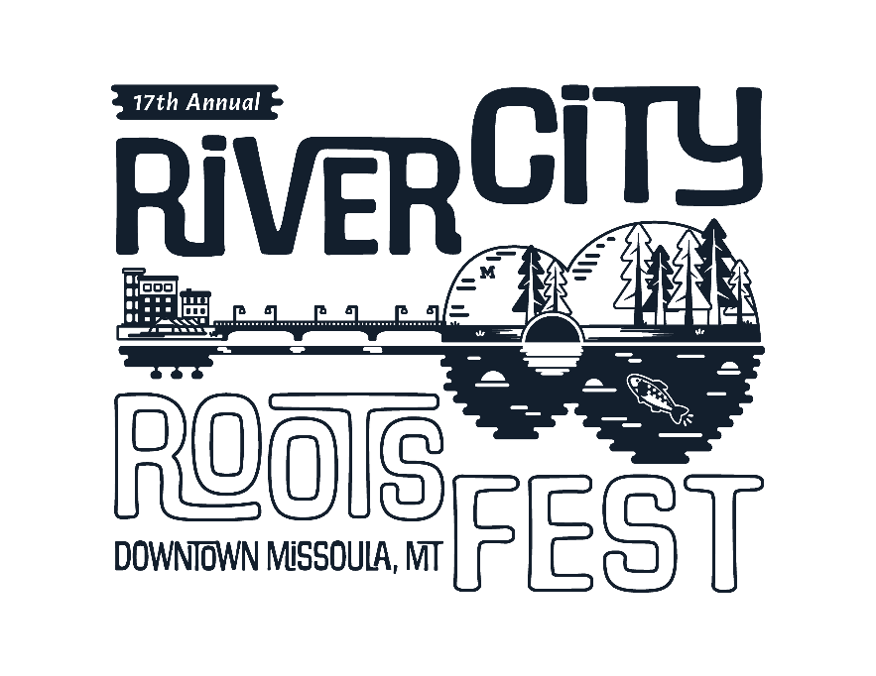

**MUSIC ON MAIN**

**FRIDAY, AUG. 25**

Kids’ Rock Bands 12:30-2 pm

Joan Zen 2:30-4 pm

Soul Funk Collective 4:30-6 pm

Taj Weekes & Adowa 6:30-8 pm

Super Chikan 8:30-10:30 pm

**SATURDAY, AUG. 26**

Cowboy Andy & the Salamanders 12:30-2 pm

Fireside Collective 2:30-4 pm

Laney Lou & the Bird Dogs 4:30-6 pm

Big Richard 6:30-8 pm

The Travelin’ McCourys 8:30-10:30 pm

**FRIDAY, AUGUST 25**

12 pm-7 pm ART SHOW Main Street

12 pm-10 pm FOOD COURT OPEN Ryman Street

2 pm-10 pm STREET BARS OPEN Main Street

**SATURDAY, AUGUST 26**

8 am-1 pm Saturday Markets Downtown Missoula

8:30 am FOUR-MILE ROOTS RUN E. Main/Caras Park

10 am-2 pm FAMILY ROOTS FESTIVAL Caras Park

10 am-7 pm ART SHOW Main Street

10 am-10 pm FOOD COURT OPEN Ryman Street

12 pm-10 pm STREET BARS OPEN Ryman Street

**EXTEND YOUR WEEKEND IN DOWNTOWN MISSOULA**

* Downtown ToNight featuring The Timber Rattlers Thursday, Aug. 24 from 5:30-8:30 pm in Caras Park
* Support Our Roots Sidewalk Sale Friday, Saturday & Sunday throughout Downtown
* Unseen Missoula “Music in Our Roots” Tour Friday @3pm and Saturday @10am & 3pm