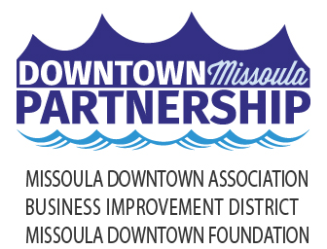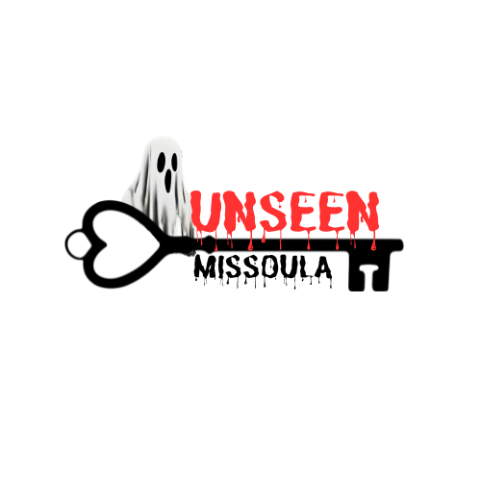

Local Media – September 25, 2024

**UNSEEN MISSOULA UNVEILS NEW “SCREAMS & SPIRITS” TOUR FOR OCTOBER**

**A Chilling Journey into Missoula’s Hidden History with Thrilling Tales and Haunting Encounters**

Unseen Missoula invites both locals and visitors to step into the eerie and untold past of the city with the all-new Screams & Spirits Tour, offered throughout October running Thursday through Saturday evenings, and select Sundays. The tour will immerse participants in Downtown Missoula’s spookiest corners and darkest secrets, just as autumn’s crisp air and falling leaves set the perfect stage for the season of the supernatural.

The Screams & Spirits Tour takes a deep dive into Downtown Missoula’s chilling history, with forgotten cemeteries, eerie landmarks, and scandalous figures that many have never heard of. Led by knowledgeable guides, guests will explore the city’s haunting past, where tales of scandal, crime, and mystery come to life.

The tour winds through Downtown Missoula’s historic streets, stopping at sites of local legend and once-forgotten graveyards. It concludes at the Cranky Sam Public House, located in the heart of Missoula’s historic red-light district, where guests might feel the presence of long-gone spirits or hear the echoes of their cries from centuries past. This journey through time promises an unforgettable experience as Missoula’s eerie history is brought to life under the evening sky.

The Screams & Spirits Tours commence on Thursday, October 3, and will run throughout October. Tours start in front of the First Interstate Bank across from The Wilma and last approximately 90 minutes. Tickets are $25 per person and can be purchased online at www.missouladowntown.com/tours/unseen-missoula. In partnership with Cranky Sam Public House, each ticket holder will receive a $2 off coupon for drinks at Cranky Sam and a limited edition Screams & Spirits can koozie as a souvenir to remember the evening’s thrilling adventure. The tour is ADA accessible, making it a welcoming experience for all.

Tickets are available now, and with limited spaces, early booking is encouraged to ensure a spot on this spine-tingling tour. Don’t miss the chance to explore Missoula’s darker side this Halloween season.

Offered by the Downtown Missoula Partnership, Unseen Missoula offers guided historical walking tours throughout Downtown Missoula.

For more information about Unseen Missoula and the Screams & Spirits Tour, contact Amber Gagen at [amber@missouladowntown.com](mailto:amber@missouladowntown.com?subject=Screams%20&%20Spirits) or call (406) 543-4238.

*Downtown Missoula: Connecting Our Community!*