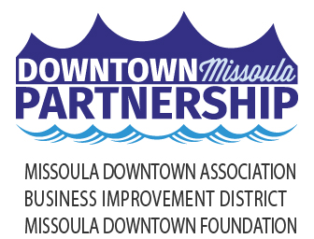

January 24, 2025

Local Media

**SAVOR THE FLAVORS OF DOWNTOWN!**

Dine Local Week Returns January 27 - February 2, 2025

The Downtown Missoula Partnership is hosting the fifth annual ***Downtown Dine Local Week*** to shift attention toward supporting food and beverage businesses in Downtown Missoula. The week-long promotion encourages the community to try something new and experience the diverse flavors offered at the restaurants, cafes, and bars found throughout the Heart of Missoula. Held January 27 - February 2, Downtown Dine Local Week provides opportunities to support over 100 locally owned dining businesses.

While over 20 locations are officially hosting menu specials, promotions, and giveaways, all Downtown food and beverage businesses will benefit from the support of the community. By engaging with Downtown Dine Local Week, community members will be providing businesses with additional dollars during a traditionally slower time of year.

Supporting businesses during Downtown Dine Local Week also means Missoulians have opportunities to win Downtown gift cards and other prizes. Promotions include *Take-Out Tuesday & Thursday*, *Lunchtime Love*, *French Fry Friday*, and *Brunch-tastic Weekend*. The *Dine Local Fanatic Giveaway* features a package valued at over $350 in goodies from participating businesses if folks keep their receipts and show they spent $100 or more throughout the week. Missoulians are also encouraged to do the *Diner Bingo* *Challenge* where folks are encouraged to show off their Dine Local Week adventures on social media. Those who get a ‘bingo’ are entered to win a $100 Missoula Downtown Gift Card. Follow @missouladowntown on Facebook or Instagram for more information on how to play along and win.

Downtown Dine Local Week is also an opportunity for community members to use Missoula Downtown Gift Cards. “Last year, we sold over $540,000 in gift cards,” said Linda McCarthy, Executive Director of the Downtown Missoula Partnership. “Missoulians have the opportunity to invest more than half a million dollars into local businesses in the upcoming months – what a powerful story that would be if even half of that was spent in Downtown in the next few months.” There are over 200 locations where Downtown gift cards are accepted.  
  
For more information on Downtown Dine Local Week, visit [www.missouladowntown.com/dine-local-week](http://www.missouladowntown.com/dine-local-week) or contact the Downtown Missoula Partnership staff via phone (406-542-4238) or email ([info@missouladowntown.com](mailto:info@missouladowntown.com)).

*Downtown Missoula: Connecting Our Community!*