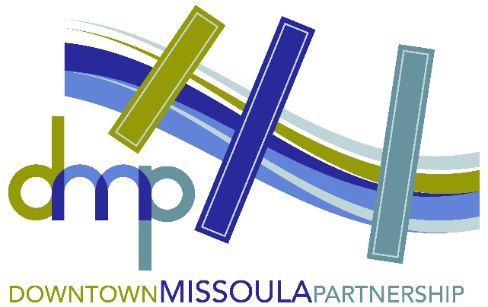
January 5, 2026
Local Media, Arts Organizations & Artists

DOWNTOWN ARTS & CULTURE IMPACT GRANTS OPEN FOR 2026 PROJECTS

The Missoula Downtown Foundation is now accepting applications for its annual Downtown Arts & Culture Impact Grants for projects to be completed in 2026. The Missoula Downtown Foundation (MDF) has allocated funding each year to create and sustain art for the public’s consumption in Downtown Missoula. The program supports placemaking projects that contribute to the beautification, cultural enhancement, historic preservation, and general livability of Downtown Missoula.

The Downtown Arts & Culture Impact Grants are intended to:
- Support the cultural, artistic and economic uniqueness of Downtown Missoula
- Create long-lasting positive improvements to the physical spaces
- Make Downtown Missoula better for future generations
- Partner artists with places and property owners
- Create projects that can be completed within six months

The application portal can be found online at https://www.missouladowntown.com/missoula-downtown-foundation/grants/. Proposals should comply with the goals of the Downtown Master Plan, the North Riverside Parks & Trails Plan and/or the Missoula Heritage Interpretive Plan, all which can be found online at https://www.missouladowntown.com/downtown-master-plan/. The deadline for applications is Friday, Feb. 20, 2026, and projects should be completed no later than Friday, Sept. 25, 2026. Projects must be in the Downtown Master Plan study area to be eligible.

“It’s been so exciting for the Foundation Board to invest in public placemaking and art,” said Hailey Kern, incoming MDF Board President and co-owner of the Bicycle Hangar. “We’ve met some great artists and have done some really cool projects in Downtown! This program is well-aligned with our mission, and we’re excited to continue our investment and expansion of artwork in Downtown. These projects are some of the most inspirational work we do.”

Over the last four years, the Foundation has funded nine projects, including three that were completed in 2025:
- Alive with the Land by Madison Perrins at Worden’s Market
- What Makes Montana by Abby French at The Wren
- Bison, Prairie Dogs, Beavers Teen Art Project (TAP) at the Missoula Art Museum

Reach out to the Downtown Missoula Partnership via email (info@missouladowntown.com) or phone (406-543-4238) if additional information is needed.

Downtown Missoula: Connecting Our Community!

